 | SLFUMC YOUTH 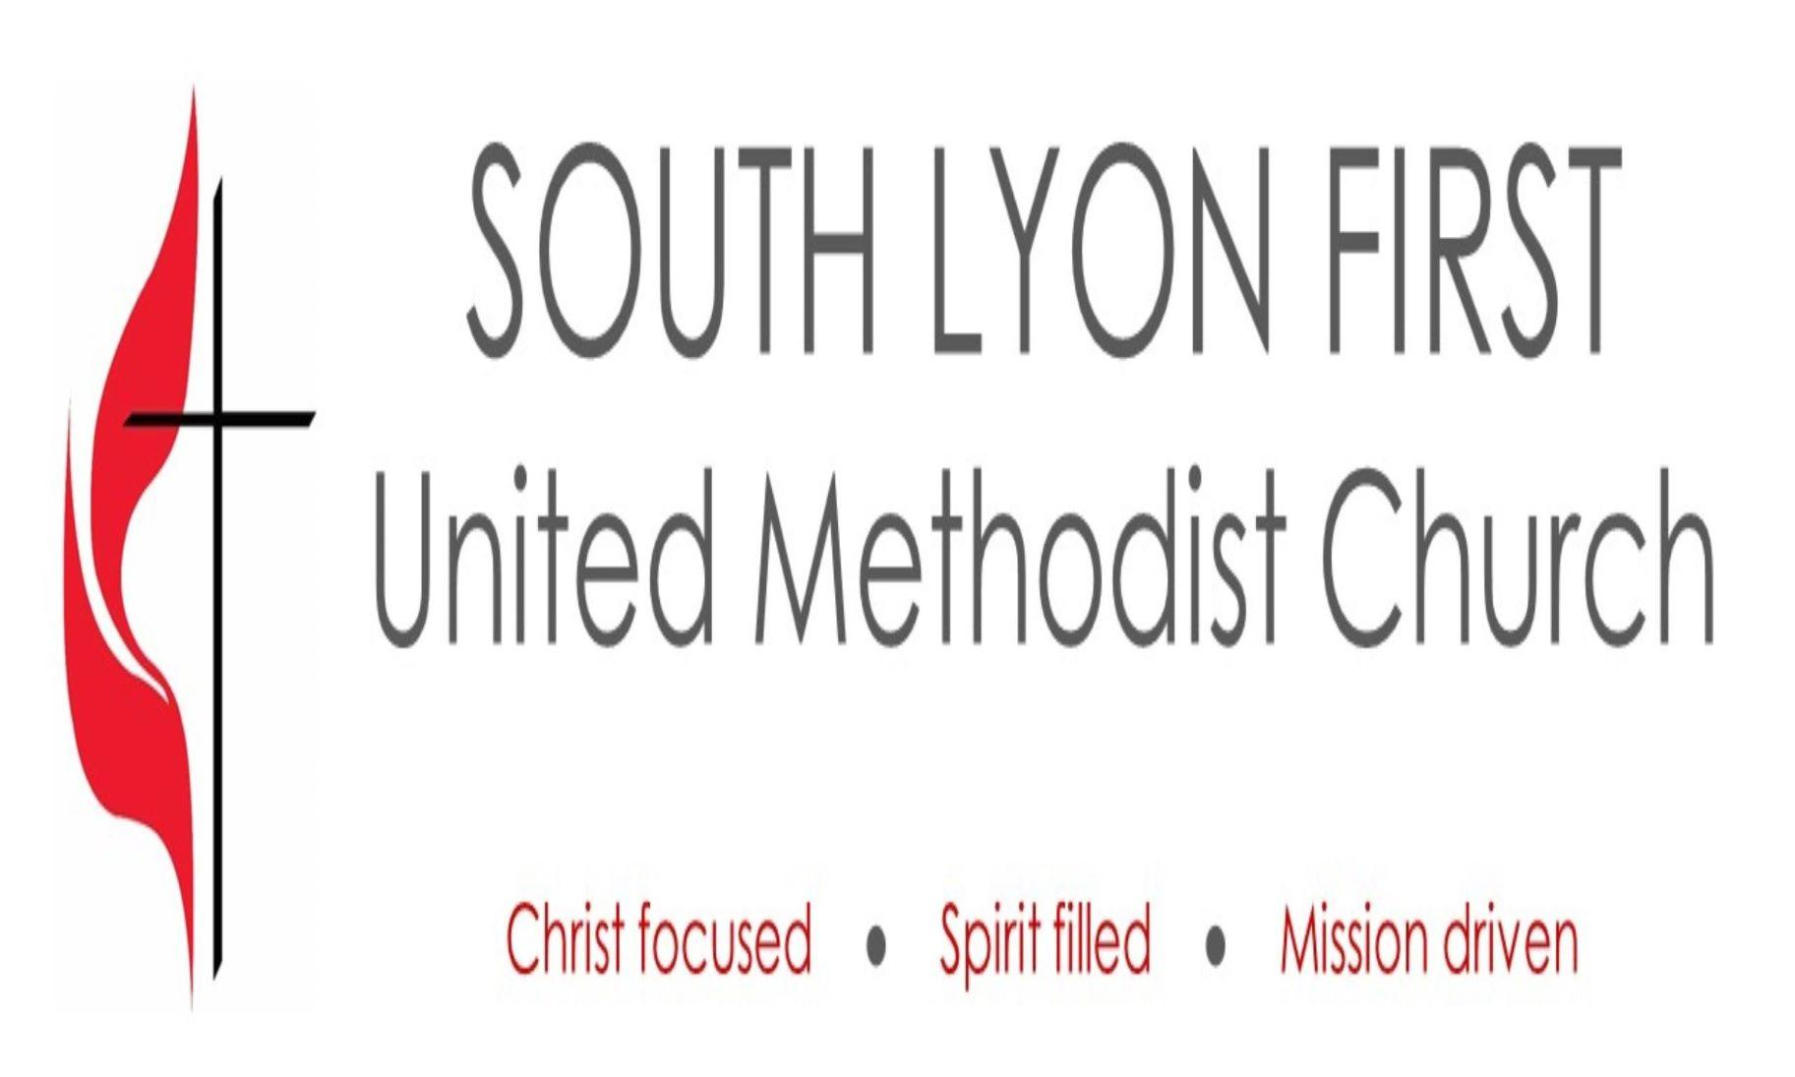
 | FEBRUARY 2025
Tina: tinasain@southlyonfirstumc.org
What’s Happening with SLFUMC Youth  Most years it seems like January has 347 days but this year it has gone by pretty quickly and February is already just over a week away!  In January we had great turnouts at our regularly scheduled Youth Group and at our bowling outing!  January 29 we worked on our service project and were able to make many treat enrichment bags for dogs and cat houses for the Humane Society. Thank you to all those that helped and donated!  February will be a little wonky because of Mid-Winter break, but we will still plan on having some fun. |  |  | What’s New?  Pictures still needed for the memory wall.  Snack donations needed and appreciated!  High school mission trip initial planning in beginning.  Plans are also in the works for serving a meal at Cass. Stay tuned for updates. |  |   We are missing some birthdates, please send youths’ birthdates to Tina.
 |  |  |   Dates to Keep in Mind  FEB 2: Youth Group  FEB 9: Youth Group Special Art project with Bobbie Bushey  FEB 16: No Youth Group: Mid-Winter Break  FEB 23: No Youth Group: Mid-Winter Break |  | “So now faith, hope, and love abide, these three; but the greatest of these is love.” -1 Corinthians 13:13  “Beloved, let us love one another, for love is from God, and whoever loves has been born of God and knows God. Anyone who does not love does not know God, because God is love.” -1 John 4:4-8

